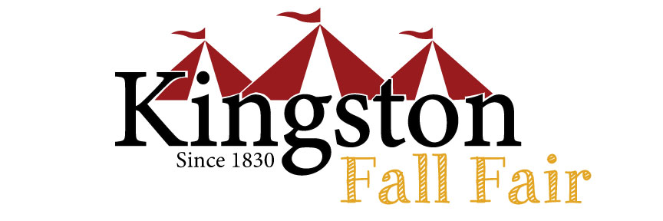
BOARD OF DIRECTORS APPLICATION FORM
The Kingston & District Agricultural Society has a few openings for Associate Directors on our board. We are a diverse group that meets monthly and works to produce a successful fall fair each fall. Last year, 23,180 people enjoyed the 4-day event, a blend of family fun, spectacular entertainment, livestock and homecraft competitions and more. We’d love to have you join us, and we offer a variety of committees and roles to explore.
The role of Associate Director is a great introduction to board participation. After you have been an Associate Director for at least one year, you are eligible to become a Director. Please complete this Application Form and forward it along with your current resume to Ellen Mortfield, office manager at kingstonfallfair@gmail.com

Candidate Name:_______________________________________________________________________ Address: _____________________________________________________________________________ City/Town: _____________________________ Postal Code:____________________________
Telephone: _________________ Email: _________________________________________________
Background information:
1. Why are you interested in serving on the Kingston & District Agricultural Society board? _____________________________________________________________________________________ _____________________________________________________________________________________ _____________________________________________________________________________________
2. Please tell us about any experience you may have with community groups or other Boards: ____________________________________________________________________________________ ____________________________________________________________________________________ ____________________________________________________________________________________ ____________________________________________________________________________________ ____________________________________________________________________________________
3. Please indicate which of the following skill sets/experience you would bring to our Board of Directors.
€ Finance € Volunteer Mgmt € Marketing/Fundraising € Labour/Trades € Agriculture € Event Mgmt
€ Arts/Crafts € Education € Other __________________________________________________
All information collected on this form will be stored confidentially and used only by KDAS for recruitment purposes.

